An Intro to Git and GitHub for Beginners (Tutorial)
Oct 1, 2015 / by Meghan Nelson

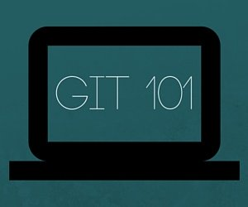
In August, we hosted a Women Who Code meetup at HubSpot and led a workshop for beginners on using git and GitHub. I first walked through a slide presentation on the basics and background of git and then we broke out into groups to run through a tutorial I created to simulate working on a large, collaborative project. We got feedback after the event that it was a helpful, hands-on introduction. So if you're new to git, too, follow the steps below to get comfortable making changes to the code base, opening up a pull request (PR), and merging code into the master branch. Any important git and GitHub terms are in bold with links to the official git reference materials.

Step 0: Install git and create a GitHub account
The first two things you'll want to do are install git and create a free GitHub account.
Follow the instructions here to install git (if it's not already installed). Note that for this tutorial we will be using git on the command line only. While there are some great git GUIs (graphical user interfaces), I think it's easier to learn git using git-specific commands first and then to try out a git GUI once you're more comfortable with the command.
Once you've done that, create a GitHub account here. (Accounts are free for public repositories, but there's a charge for private repositories.)

Step 1: Create a local git repository
When creating a new project on your local machine using git, you'll first create a new repository (or often, 'repo', for short).
To use git we'll be using the terminal. If you don't have much experience with the terminal and basic commands, check out this tutorial (especially the 'Navigating the Filesystem' and 'Moving Around' sections).
To begin, open up a terminal and move to where you want to place the project on your local machine using the cd (change directory) command. For example, if you have a 'projects' folder on your desktop, you'd do something like:

mnelson:Desktop mnelson$ cd ~/Desktop
mnelson:Desktop mnelson$ mkdir myproject
mnelson:Desktop mnelson$ cd myproject/
view raw terminalcd.md hosted with ❤ by GitHub

To initialize a git repository in the root of the folder, run the git init command:

mnelson:myproject mnelson$ git init
Initialized empty Git repository in /Users/mnelson/Desktop/myproject/.git/
view raw gitinit.md hosted with ❤ by GitHub

Step 2: Add a new file to the repo
Go ahead and add a new file to the project, using any text editor you like or running a touch command.
Once you've added or modified files in a folder containing a git repo, git will notice that changes have been made inside the repo. But, git won't officially keep track of the file (that is, put it in a commit - we'll talk more about commits next) unless you explicitly tell it to.

mnelson:myproject mnelson$ touch mnelson.txt
mnelson:myproject mnelson$ ls
mnelson.txt
view raw addfile.md hosted with ❤ by GitHub

After creating the new file, you can use the git status command to see which files git knows exist.

mnelson:myproject mnelson$ git status
On branch master

Initial commit

Untracked files:
(use "git add <file>..." to include in what will be committed)

mnelson.txt

nothing added to commit but untracked files present (use "git add" to track)
view raw gitstatus.md hosted with ❤ by GitHub
What this basically says is, "Hey, we noticed you created a new file called mnelson.txt, but unless you use the 'git add' command we aren't going to do anything with it."

An interlude: The staging environment, the commit, and you
One of the most confusing parts when you're first learning git is the concept of the staging environment and how it relates to a commit.
A commit is a record of what files you have changed since the last time you made a commit. Essentially, you make changes to your repo (for example, adding a file or modifying one) and then tell git to put those files into a commit.
Commits make up the essence of your project and allow you to go back to the state of a project at any point.
So, how do you tell git which files to put into a commit? This is where the staging environment or index come in. As seen in Step 2, when you make changes to your repo, git notices that a file has changed but won't do anything with it (like adding it in a commit).
To add a file to a commit, you first need to add it to the staging environment. To do this, you can use the git add <filename> command (see Step 3 below).
Once you've used the git add command to add all the files you want to the staging environment, you can then tell git to package them into a commit using the git commit command.
Note: The staging environment, also called 'staging', is the new preferred term for this, but you can also see it referred to as the 'index'.

Step 3: Add a file to the staging environment
Add a file to the staging environment using the git add command.
If you rerun the git status command, you'll see that git has added the file to the staging environment (notice the "Changes to be committed" line).

mnelson:myproject mnelson$ git status
On branch master

Initial commit

Changes to be committed:
(use "git rm --cached <file>..." to unstage)

new file: mnelson.txt
view raw addtostaging.md hosted with ❤ by GitHub
To reiterate, the file has not yet been added to a commit, but it's about to be.

Step 4: Create a commit
It's time to create your first commit!
Run the command git commit -m "Your message about the commit"

mnelson:myproject mnelson$ git commit -m "This is my first commit!"
[master (root-commit) b345d9a] This is my first commit!
1 file changed, 1 insertion(+)
create mode 100644 mnelson.txt
view raw commit.md hosted with ❤ by GitHub
The message at the end of the commit should be something related to what the commit contains - maybe it's a new feature, maybe it's a bug fix, maybe it's just fixing a typo. Don't put a message like "asdfadsf" or "foobar". That makes the other people who see your commit sad. Very, very, sad.

Step 5: Create a new branch
Now that you've made a new commit, let's try something a little more advanced.
Say you want to make a new feature but are worried about making changes to the main project while developing the feature. This is where git branches come in.
Branches allow you to move back and forth between 'states' of a project. For instance, if you want to add a new page to your website you can create a new branch just for that page without affecting the main part of the project. Once you're done with the page, you can merge your changes from your branch into the master branch. When you create a new branch, Git keeps track of which commit your branch 'branched' off of, so it knows the history behind all the files.
Let's say you are on the master branch and want to create a new branch to develop your web page. Here's what you'll do: Run git checkout -b <my branch name>. This command will automatically create a new branch and then 'check you out' on it, meaning git will move you to that branch, off of the master branch.
After running the above command, you can use the git branch command to confirm that your branch was created:

mnelson:myproject mnelson$ git branch
master
* my-new-branch
view raw gitbranch.md hosted with ❤ by GitHub
The branch name with the asterisk next to it indicates which branch you're pointed to at that given time.
Now, if you switch back to the master branch and make some more commits, your new branch won't see any of those changes until you merge those changes onto your new branch.

Step 6: Create a new repository on GitHub
If you only want to keep track of your code locally, you don't need to use GitHub. But if you want to work with a team, you can use GitHub to collaboratively modify the project's code.

To create a new repo on GitHub, log in and go to the GitHub home page. You should see a green '+ New repository' button:
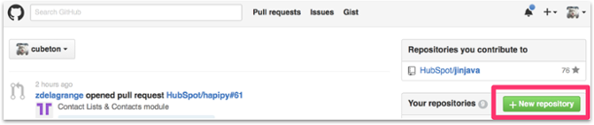

After clicking the button, GitHub will ask you to name your repo and provide a brief description:
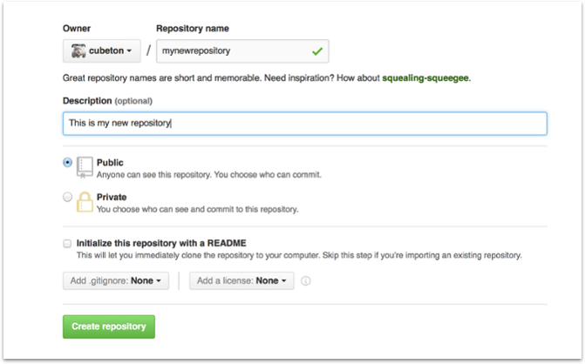
When you're done filling out the information, press the 'Create repository' button to make your new repo.
GitHub will ask if you want to create a new repo from scratch or if you want to add a repo you have created locally. In this case, since we've already created a new repo locally, we want to push that onto GitHub so follow the '....or push an existing repository from the command line' section:

mnelson:myproject mnelson$ git remote add origin https://github.com/cubeton/mynewrepository.git
mnelson:myproject mnelson$ git push -u origin master
Counting objects: 3, done.
Writing objects: 100% (3/3), 263 bytes | 0 bytes/s, done.
Total 3 (delta 0), reused 0 (delta 0)
To https://github.com/cubeton/mynewrepository.git
* [new branch] master -> master
Branch master set up to track remote branch master from origin.

view raw addgithub.md hosted with ❤ by GitHub
(You'll want to change the URL in the first command line to what GitHub lists in this section since your GitHub username and repo name are different.)

Step 7: Push a branch to GitHub
Now we'll push the commit in your branch to your new GitHub repo. This allows other people to see the changes you've made. If they're approved by the repository's owner, the changes can then be merged into the master branch.
To push changes onto a new branch on GitHub, you'll want to run git push origin yourbranchname. GitHub will automatically create the branch for you on the remote repository:

mnelson:myproject mnelson$ git push origin my-new-branch
Counting objects: 3, done.
Delta compression using up to 8 threads.
Compressing objects: 100% (2/2), done.
Writing objects: 100% (3/3), 313 bytes | 0 bytes/s, done.
Total 3 (delta 0), reused 0 (delta 0)
To https://github.com/cubeton/mynewrepository.git
* [new branch] my-new-branch -> my-new-branch
view raw addnewbranchgithub.md hosted with ❤ by GitHub
You might be wondering what that "origin" word means in the command above. What happens is that when you clone a remote repository to your local machine, git creates an alias for you. In nearly all cases this alias is called "origin." It's essentially shorthand for the remote repository's URL. So, to push your changes to the remote repository, you could've used either the command: git push git@github.com:git/git.git yourbranchname or git push origin yourbranchname
(If this is your first time using GitHub locally, it might prompt you to log in with your GitHub username and password.)
If you refresh the GitHub page, you'll see note saying a branch with your name has just been pushed into the repository. You can also click the 'branches' link to see your branch listed there.
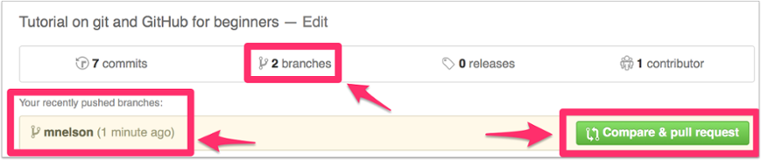
Now click the green button in the screenshot above. We're going to make a pull request!

Step 8: Create a Pull Request (PR)
A pull request (or PR) is a way to alert a repo's owners that you want to make some changes to their code. It allows them to review the code and make sure it looks good before putting your changes on the master branch.
This is what the PR page looks like before you've submitted it:
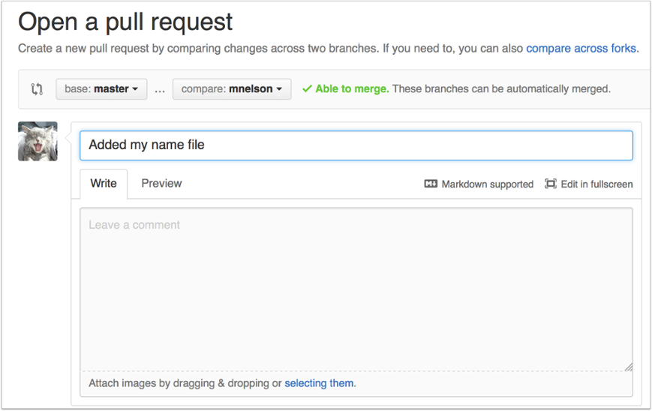
And this is what it looks like once you've submitted the PR request:
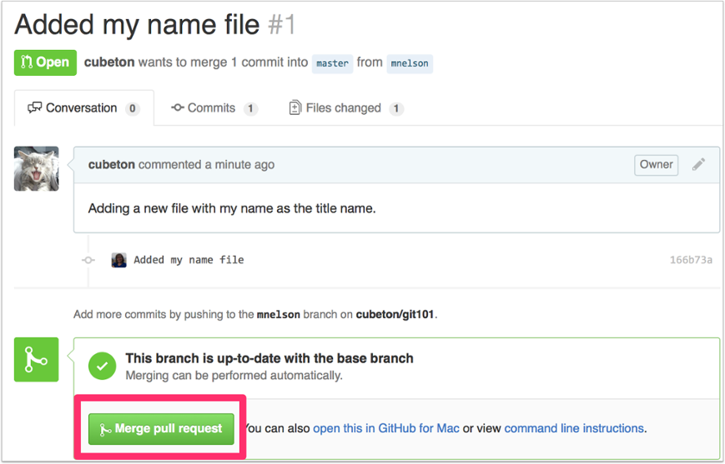
You might see a big green button at the bottom that says 'Merge pull request'. Clicking this means you'll merge your changes into the master branch.
Note that this button won't always be green. In some cases it'll be grey, which means you're faced with a merge conflict. This is when there is a change in one file that conflicts with a change in another file and git can't figure out which version to use. You'll have to manually go in and tell git which version to use.
Sometimes you'll be a co-owner or the sole owner of a repo, in which case you may not need to create a PR to merge your changes. However, it's still a good idea to make one so you can keep a more complete history of your updates and to make sure you always create a new branch when making changes.

Step 9: Merge a PR
Go ahead and click the green 'Merge pull request' button. This will merge your changes into the master branch.
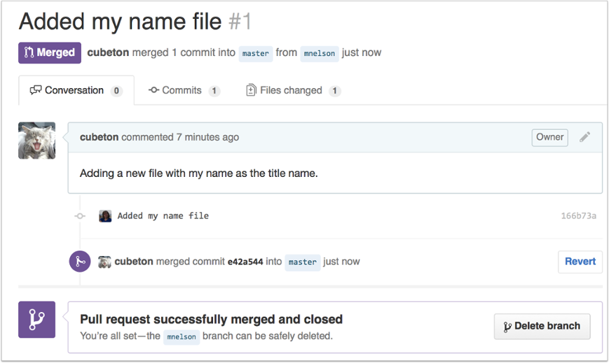

When you're done, I recommend deleting your branch (too many branches can become messy), so hit that grey 'Delete branch' button as well.
You can double check that your commits were merged by clicking on the 'Commits' link on the first page of your new repo.
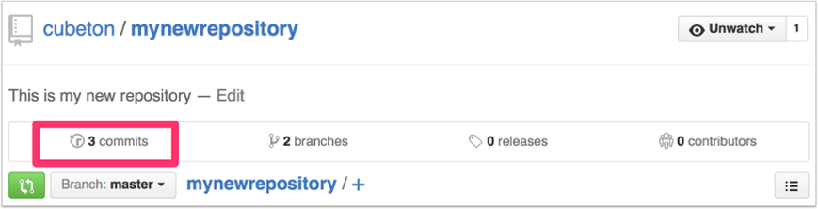

This will show you a list of all the commits in that branch. You can see the one I just merged right up top (Merge pull request #2).
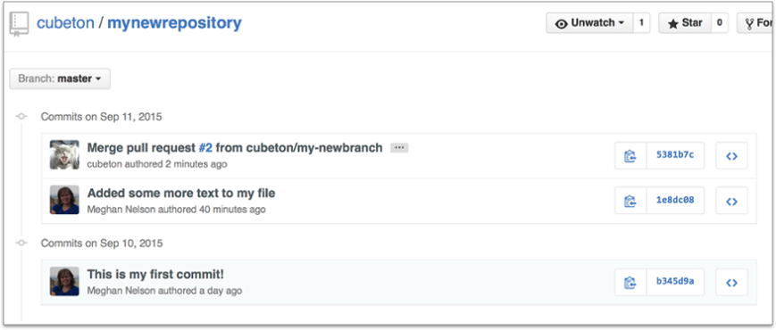
You can also see the hash code of the commit on the right hand side. A hash code is a unique identifier for that specific commit. It's useful for referring to specific commits and when undoing changes (use the git revert <hash code number> command to backtrack).

Step 10: Get changes on GitHub back to your computer
Right now, the repo on GitHub looks a little different than what you have on your local machine. For example, the commit you made in your branch and merged into the master branch doesn't exist in the master branch on your local machine.
In order to get the most recent changes that you or others have merged on GitHub, use the git pull origin master command (when working on the master branch).

mnelson:myproject mnelson$ git pull origin master
remote: Counting objects: 1, done.
remote: Total 1 (delta 0), reused 0 (delta 0), pack-reused 0
Unpacking objects: 100% (1/1), done.
From https://github.com/cubeton/mynewrepository
* branch master -> FETCH_HEAD
b345d9a..5381b7c master -> origin/master
Merge made by the 'recursive' strategy.
mnelson.txt | 1 +
1 file changed, 1 insertion(+)
view raw pulloriginmaster.md hosted with ❤ by GitHub
This shows you all the files that have changed and how they've changed.
Now we can use the git log command again to see all new commits.
(You may need to switch branches back to the master branch. You can do that using the git checkout master command.)

mnelson:myproject mnelson$ git log
commit 3e270876db0e5ffd3e9bfc5edede89b64b83812c
Merge: 4f1cb17 5381b7c
Author: Meghan Nelson <mnelson@hubspot.com>
Date: Fri Sep 11 17:48:11 2015 -0400

Merge branch 'master' of https://github.com/cubeton/mynewrepository

commit 4f1cb1798b6e6890da797f98383e6337df577c2a
Author: Meghan Nelson <mnelson@hubspot.com>
Date: Fri Sep 11 17:48:00 2015 -0400

added a new file

commit 5381b7c53212ca92151c743b4ed7dde07d9be3ce
Merge: b345d9a 1e8dc08
Author: Meghan Nelson <meghan@meghan.net>
Date: Fri Sep 11 17:43:22 2015 -0400

Merge pull request #2 from cubeton/my-newbranch

Added some more text to my file

commit 1e8dc0830b4db8c93efd80479ea886264768520c
Author: Meghan Nelson <mnelson@hubspot.com>
Date: Fri Sep 11 17:06:05 2015 -0400

Added some more text to my file

commit b345d9a25353037afdeaa9fcaf9f330effd157f1
Author: Meghan Nelson <mnelson@hubspot.com>
Date: Thu Sep 10 17:42:15 2015 -0400

This is my first commit!
view raw gitlogaftermerge.md hosted with ❤ by GitHub

Step 11: Bask in your git glory
You've successfully made a PR and merged your code to the master branch. Congratulations! If you'd like to dive a little deeper, check out the files in this Git101 folder for even more tips and tricks on using git and GitHub.
I also recommend finding some time to work with your team on simulating a smaller group project like we did here. Have your team make a new folder with your team name, and add some files with text to it. Then, try pushing those changes to this remote repo. That way, your team can start making changes to files they didn't originally create and practice using the PR feature. And, use the git blame and git history tools on GitHub to get familiar with tracking which changes have been made in a file and who made those changes.
The more you use git, the more comfortable you'll... git with it. (I couldn't resist.)


Written by Meghan Nelson

Comments

Sam
2015-10-02, 12:34:59 a.m.
Very informative post! Thanks!

Alberto Guijarro Rodriguez
2018-04-22, 2:27:33 p.m.
Thank you very much for the tutorial, clear and easy to follow.

Aditya
2018-08-30, 3:22:26 p.m.
Meghan, this webpage was recommended by a bootcamp I joined and while I did find it frustrating since I have never used Git before, I loved the way this article was written. It was very informative for a dummy to Git like me :)

june
2015-12-13, 11:14:56 a.m.
Thanks for the tutorial, but I have one question. I've done to step 8 (Step 8: Create a Pull Request (PR), but the github page could not find any changes, it says "master and my-branch-name are identical." I tried several times but still couldn't find the reason. I don't know where did I do wrong, anyone has the same problem?

Meghan Nelson
2015-12-14, 1:04:26 p.m.
Hi June! I'm glad you're going through the tutorial. It sounds like what's happening is you've created your new branch on GitHub, but you haven't made changes (commits) on that branch or pushed your local changes (commits) onto GitHub.
What you can do is:
1. Make sure you're working on the correct branch (use the 'git branch' command). There should be an asterisk next to your branch name you're currently working on.
2. Make sure you've made commits on your branch. You can use the 'git status' command to see if there are any unsaved changes (You want it to say 'On branch my-branch-name
nothing to commit, working directory clean'). You can use the 'git log' command to make sure that you have made commits on that branch. You'll need to make at least one commit for there to be differences to appear.
3. Finally once you're sure you've made a commit on that branch, try redoing the 'git push origin my-branch-name' command and refresh the page on GitHub. You should then your changes listed in your branch on GitHub.
I hope this helps, let me know if you run into any problems!

June
2015-12-14, 8:24:09 p.m.
Hi Meghan,
Thanks for the answer. Yesterday I tried it again and finally could make the git push command!
I'm completely new in coding, have just studied it for a few months, and finding something really easy to follow like your tutorial is such a great happiness.
Thanks so much!

michael owen
2015-12-30, 7:50:48 a.m.
Thanks for the answer. Yesterday I tried it again and finally could make the git push command!
I'm completely new in coding, have just studied it for a few months, and finding something really easy to follow like your tutorial is such a great happiness.
Thanks so much!
Thanks for the answer. Yesterday I tried it again and finally could make the git push command!
I'm completely new in coding, have just studied it for a few months, and finding something really easy to follow like your tutorial is such a great happiness.
Thanks so much!

Kristin Day
2016-05-31, 9:05:20 a.m.
This was so helpful! Thank you so much for posting!!

Virendra More
2016-08-14, 9:19:51 a.m.
Can I configure remote repository with corporate domain user accounts?

Paul Swanson
2016-10-16, 4:46:38 p.m.
Wonderful guide! This was very useful for my purposes. I didnt wanna to have to load 100 files at a time using to stupid gui, This let me upload all 9k in a single go. And it will prove invaluable as I go forward with my project. When doing a git commit will this work?
git commit i_want_everything_in_this_folder*

Arjun Satarkar
2017-09-15, 1:49:19 p.m.
Where did you get 9k files from? Just curious.

Niraj Warade
2016-12-11, 8:31:19 a.m.
Thanks Meghan for your efforts!
The tutorial was really helpful.

Gyan Prakash
2016-12-27, 3:27:10 a.m.
very helpful tutorial with all required links. Hopefully I will be able to use git and github.

Joe Austin
2017-01-14, 2:35:18 p.m.
Thanks for the tutorial. Trying to keep GitHub repo, local repo, master, branch, staging, working copy and all that straight is mind-boggling, but your explanation helps.
Guess my next step is to clone a project from some other website
to my website, make changes, then push/pull them back to the original website with GitHub--just one more layer of complexity! I'd assume this requires complicity of the original website.

Daljeet
2017-02-15, 2:57:52 p.m.
A BIG thanks to you for providing such a wonderful tutorial. Now i know what my team is going to work on and how to do work as a team !

Kathy
2017-02-28, 5:17:56 p.m.
I really want to complete this tutorial but I got stuck on step 1 :( It says "To use git we'll be using the terminal. If you don't have much experience with the terminal and basic commands, check out this tutorial" but the link goes to a mac site. What are us Windows users supposed to do?

Topher Eliot
2017-04-21, 12:21:47 a.m.
I recommend that rather than learning to use Windows command line tools, you instead learn Linux command line tools. The good news is that you can do this on Windows! The trick is to get a package called Cygwin (https://cygwin.com/install.html) and install and run it. That will get you a command line window that does a pretty good job of mimicking Linux. This gives you most of the power of Linux command line tools, which will be very handy as you expand your skills.

Diana Hoober
2017-04-21, 12:35:30 a.m.
Thanks Topher I appreciate the tip for Linux. My main concern is learning it for the contracts I do at Microsoft so figured out that it is the command line for Windows and there is no problem learning the terminology for that since I have been using that off and on for over 37 years.

Jaspreet Singh
2017-03-08, 6:55:25 a.m.
Hello
Thanks for sharing a great article in which you write step by step about Git and Github tutorial. I understand easily after reading your article. I am a beginner for Git and Github.
Thanks again for sharing useful matter with me and whole people.

Praveen
2017-03-16, 6:42:40 a.m.
Thanks for your article. I also think it helps people a lot if you can make a video of this process.
It is a very simple process and takes like 10 minutes of actually showing how it is done. For beginners using Windows I suggest using Github for Windows so there is no need to start using command line straight away and it is 127 mb size download the last time I downloaded.
Tutorial for Windows: https://www.youtube.com/watch?v=LufnCoPShZE
Website to download Github for Windows: https://desktop.github.com/
It is very simple to use and have fun, you can get into command line way of doing things after you get used this process.
Have Fun and God Bless :)

Lucian Agnello
2017-03-20, 4:10:22 p.m.
Thank you for the walkthrough tutorial. It was super easy and a fantastic crash course, as I have to use it for a new job

Pu Dinh
2017-03-23, 5:33:39 a.m.
Thank you so much. So now I can to use it for a new job.

DHIRAJ MASODGI
2017-03-25, 7:26:52 p.m.
Very handy for beginners to start with. Great work.

Elian Maciel
2017-03-31, 2:05:43 p.m.
Elian from software engineering class

al rii
2017-04-06, 8:57:31 p.m.
This is beautifully explained in brief steps. This is what tutorials should be.

Mahdi Nematpour
2017-04-07, 4:03:35 p.m.
Thanks for your useful and brief post.

Diana Hoober
2017-04-18, 3:23:28 p.m.
I just started the tutorial and am having trouble understanding some of the terminology. It says you have to used a terminal. What is that? Does it mean open a command prompt window and work at that level? I'm using Windows and have used it since DOS 2.1 so I am familiar with the command prompt, etc. having only been able to work at that level at the time I started using personal computers.

John Sobanski
2017-04-24, 11:17:44 a.m.
Good writeup. Nice use of both the command line and the web GUI.

Zak Longo
2017-05-03, 2:59:45 p.m.
Great refresher. I have been in TFS land for 4 years, and needed a refresher on GIT. I wasn't comfortable simply relying on IntelliJ's GIT GUI, because I remember how powerful GIT can be when you know how to use the terminal commands.

Jim Kerns
2017-05-10, 6:26:39 p.m.
I'm sorry, but didn't you leave out an important step before the commit, like telling git who you are?
git config --global user.email "you@example.com"
git config --global user.name "Your Name"
otherwise you get "*** Please tell me who you are."
Your instructions did not work for me without it.
Thanks.

Ousmane Abdou
2017-05-21, 11:16:39 a.m.
Very informative. Thank you so much!

Mayur B
2017-05-23, 7:36:49 p.m.
Thanks! Your kind of beginners guide really helped.
Thanks again!

Shobhit Khare
2017-05-24, 3:44:10 a.m.
Thanks for sharing such a very helpful article for beginners.

Ashish S
2017-06-05, 6:47:11 a.m.
Excellent article! Anyone who is new to Git, should go through it for the simple explanation that it provides!

Julien Danjou
2017-06-13, 5:57:34 a.m.
In order to manage your pull requests from the command line, you can use the git-pull-request tool. It's pretty neat: https://github.com/jd/git-pull-request

Angela
2017-06-13, 12:23:57 p.m.
This is a great tutorial/article. It has really helped me to understand how Git and GitHub works without all of the fancy jargon. Thank you so much for writing it.

Abhilash Srivastava
2017-06-16, 4:02:45 p.m.
Just love the way you have explained the concepts in simple words!.
I feel this tutorial is better than the official Git tutorials.
Thanks a lot!

Ian Dalrymple
2017-06-27, 5:25:30 a.m.
Good work - thank you for putting this together

nihar more
2017-06-28, 10:47:15 a.m.
Great Post
Thanks a lot it helped me a lot
I am also going to share it to my friends and over my social media.
Also,
Hackr.io is a great platform to find and share the best tutorials and they have a specific page for Git
This might be useful to your readers: https://hackr.io/tutorials/learn-git

Thanks Megan Very
2017-06-29, 9:31:29 a.m.
could understand

James Hoyland
2017-06-29, 2:38:23 p.m.
Thanks Megan! Was looking for an exercise to introduce git for my coding for physics students - this has saved me a couple of hours prep! :) Great work.

John Escario
2017-07-05, 3:04:08 a.m.
Just want to say thanks. This tutorial was very helpful. Great resource!

Mrinalini Kaushal
2017-07-12, 2:58:28 p.m.
Nice article. It cleared most of my doubts which I had related to Git and GitHub and how to use it.
Thanks a lot. Very helpful.

Victor Nnadi
2017-07-19, 5:44:37 p.m.
The terminal tutorial you referred us to seems to be for OSX, I am using Windows OS. SO what terminal should I use?

Abhishek
2017-07-22, 3:14:50 a.m.
I have a doubt. After I merged the pull request on github, I deleted the other branch I made. And on my local computer I did "git pull origin master". But still the other branch that I deleted on github exists on my local computer. Is that supposed to work this way, or I am I doing something wrong? Do I have to manually delete the branch on my local computer? If yes, how?

Flurin Conradin
2018-02-18, 4:16:54 p.m.
I had the same question....

codeverb Team
2017-07-23, 7:07:02 a.m.
it's a great resource for github

Parth Chonkar
2017-07-23, 5:47:04 p.m.
Super useful article

Ketan Chavda
2017-07-25, 10:04:24 a.m.
Its really very good post.I am new in git.I got almost basic commands and details about git.
Thanks a lot for this post.

Vijay
2017-07-30, 4:15:40 a.m.
Thanks for sharing such nice short yet essential tutorial.
I was looking for such tutorial to jump start with git and github together.
Thanks once again.

JUN JULIAN
2017-08-24, 1:17:22 a.m.
One of the tutorial that i have bookmarked. Nicely done! Thanks.

Justin H
2017-09-07, 1:07:00 p.m.
Help... I am a huge noob to programming but I am an IT so I know some Command lines for regular work I do as a network admin and server admin, so Batch files in windows are my friend. I know basic powershell and have tried over the years to understand PY and C# but have failed to stay interested in it. I have only managed to make programs and games in batch files. I have now joined Github so I can learn new methods and see examples, but I want to run one of them to see what it looks like and see if that's the style of code I want to actually learn (seeing is believing for me). I have "cloned" a "RPG" repository to my desktop github app, but can't seem to find a way to run this program that has been modified and written out in code. how do I actually used all these py files in the branch section and actually run this program!?!?

Gautam Tadigoppula
2017-09-17, 7:47:36 a.m.
Thanks Megan for such a great post !
I followed the tutorial and successfully created a repo from my local machine onto github account. Thanks again !

Ivan Horvat
2017-10-11, 10:57:25 a.m.
Great tutorial, really simple and forward. Thank you!

Juan Triana
2017-11-17, 11:29:43 p.m.
A thousand thumbs up ! Thank you very much, this was really helpful for a beginner like me!

Preethi Sreenath
2017-11-23, 12:59:43 a.m.
Thank your very much for a wonderful step by step tutorial. I am a beginner and could try my first sample following the steps given by you.

Mlm City
2017-12-13, 5:23:41 p.m.
Man, this tutorial makes me feel like I am developmentally challenged. Perhaps it's lack of sleep but I am beyond frustrated. I am assuming no one will see or respond to this comment. But I'll put it out here anyway.
On step 7 I receive the following
error: src refspec my-new-branch does not match any.
So obviously the branch wasn't automatically created as is shown in the example. What am I doing wrong?

Ramon Reyes
2017-12-18, 1:51:55 p.m.
Wow! I'm new to this git/github and by far this one the most comprehensive tutorial i've seen. However, i have a question though since I made some mistakes switching from master to branch and had never return successfully after. My question is, after Step 5: Create a new branch, should we checkout to master first before we proceed to Step 6: Create a new repo in github?

Preethi
2017-12-19, 1:20:32 a.m.
It is not necessary to checkout to master after step 5. Step 6 in done on GitHub directly. Then step 7 from command line.

wahyu
2018-01-17, 9:06:42 a.m.
Thank you very much, this was really helpful for a beginner like me!

water flosser
2018-01-27, 3:08:30 p.m.
Github is not very intuitive. This simplified our understanding of the system.

Celso Oliveira
2018-02-07, 3:23:25 p.m.
such a great article and tutorial. great work.

Kuldeep Singh
2018-03-04, 2:35:17 a.m.
Thanks for this awesome article. Very easy to follow and implement.

Shahin Ansari
2018-04-03, 10:34:57 p.m.
I was trying to create a pull request earlier tonight, and the GitHub site was giving me an error stating "there is nothing to compare". It is now some five hours later, and I am able to do it. I know I did not make any changes to my local repository. It must take some time for the two repos to sync up or something.
Thanks by the way for the article. It helped drive the concepts home. I need to read about something, then practice it, before I really understand it.

hje hje
2018-04-04, 5:46:25 p.m.
stopped making ANY SENSE at all after 10 sentences.
try eg to explain what you are saying.
no, just more of: press F10 to get a 4hr after gutgutgut.

nona Baltazar
2018-04-20, 1:47:35 p.m.
Thanks soooo much! Super helpful! Great job :)

Jen O'Dea
2018-04-25, 10:24:32 a.m.
For step 3 to use the 'git add' command you actually need to do:
git add .
That period is needed otherwise you won't be able to add (at least for me)
Step 5. to create a new branch you use this code:
git checkout -b new-branch
there aren't any these: '< >'
The merging was a little confusing, but was able to eventually figure it out.
This was really helpful though! It was clear and mostly easy to follow along with

Jack harbaer
2018-05-20, 2:33:39 a.m.
Get Github Star, Forks and watchings. https://www.peopleperhour.com/hourlie/give-you-github-star-and-fork/392888 https://www.fiverr.com/creativenode/give-github-star-and-forks

callmebob
2018-05-01, 8:03:50 a.m.
Great post! Very helpful, thanks a lot!

Ameen Abdelghani
2018-05-02, 10:30:32 p.m.
I have been stuck on setep 7 for some time now. when I try to do git -u push origin master, the instructions didnt mention the need for the log in into GitHub. I have a github account, I know my password / username / email. But for some reason every time the login is failing. I've tried to do solutions online but they're not solving this problem. Please help! =0

Carm
2018-05-10, 8:14:24 p.m.
Great post! Thanks! I am in the middle of a course on github and your post is way clearer than the course instruction.

Leon Baradat
2018-06-04, 5:36:20 p.m.
This is a great basic tutorial for git, just the sort of thing I was hoping to find! Thanks, you've helped get me ready to revive a FOSS edutainment program I've wanted to get back to for some time.

Vinayak Kadam
2018-06-28, 3:28:12 a.m.
Nice tutorial

Faith
2018-06-29, 6:21:38 a.m.
Thanks a lot! I've always found git or github very complicated and confusing, I don't even know the difference between git and github, just thought git is a short form for github but your article explained it clearly and easily. Now I understand all those words I normally see on github and I think I will be able to comfortably work with it now.
Thanks :)

Ayam Asayam
2018-07-03, 11:00:43 p.m.
Thanks a lot, very clear, the definitive git/github tutorial!

ankur datta
2018-09-12, 6:30:04 a.m.
on 6th step (while attempting to add remotely o github), getting this error message - src refspec master does not match any. Can you help please ?

